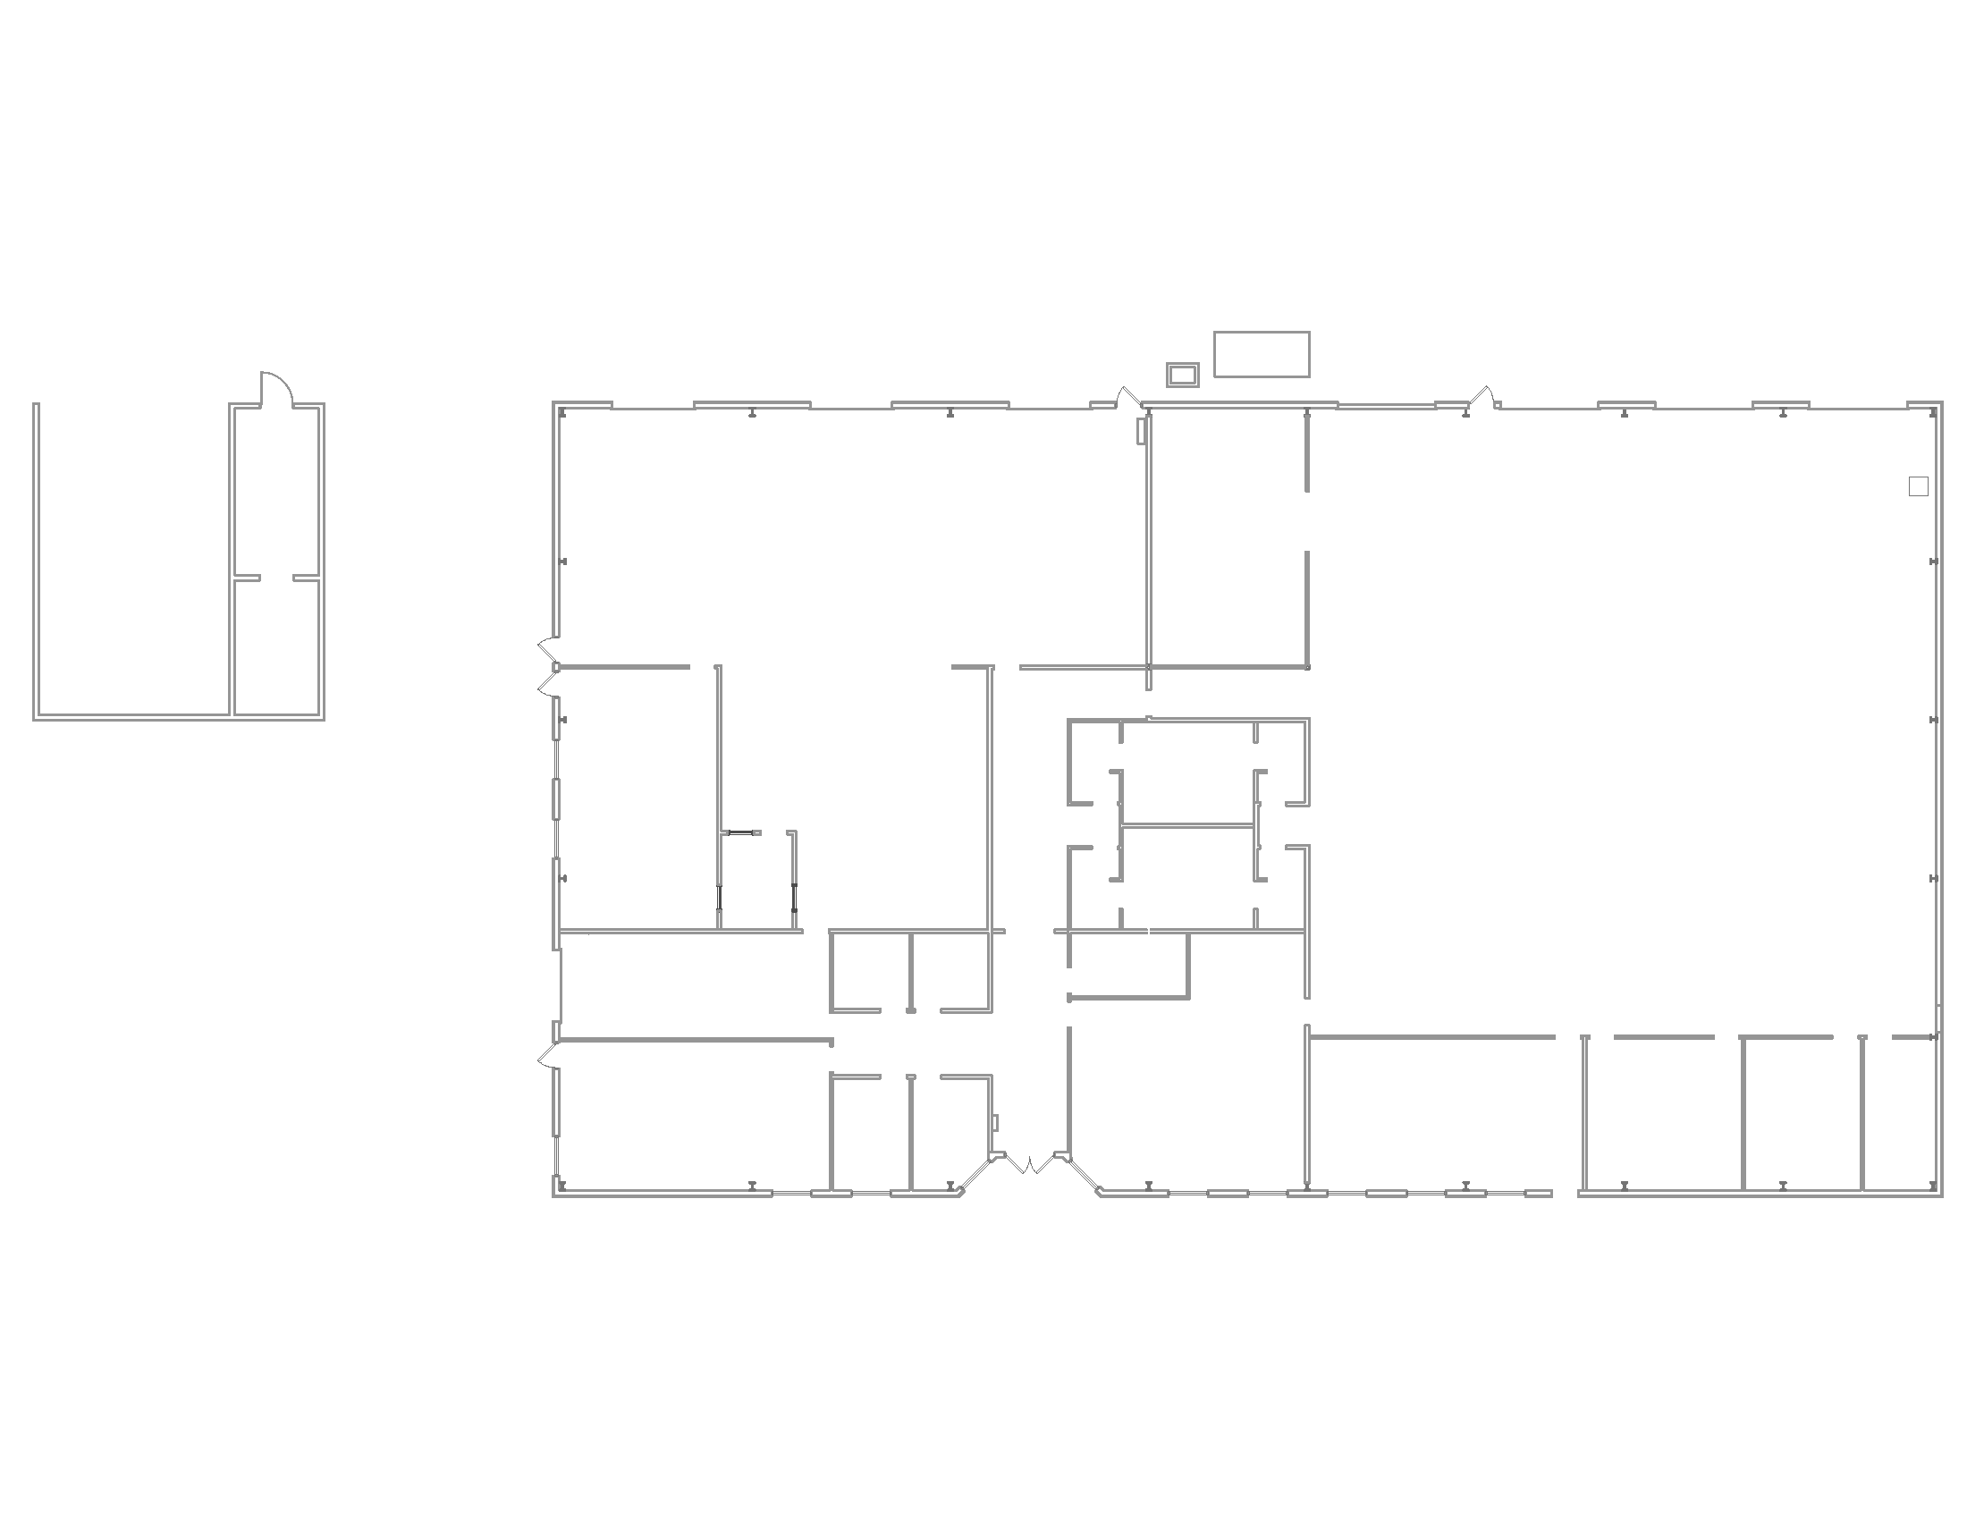

**Restroom**

**IT**

Diesel Shop Area

Diesel Classroom

Vending Area

Automotive Shop Area

Automotive Classroom

**IT**

Truck Driving

Maintenance Dept.